Lab 06:
Exercise:

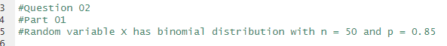

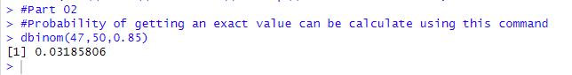

2)

